Portmarnock cruise to victory

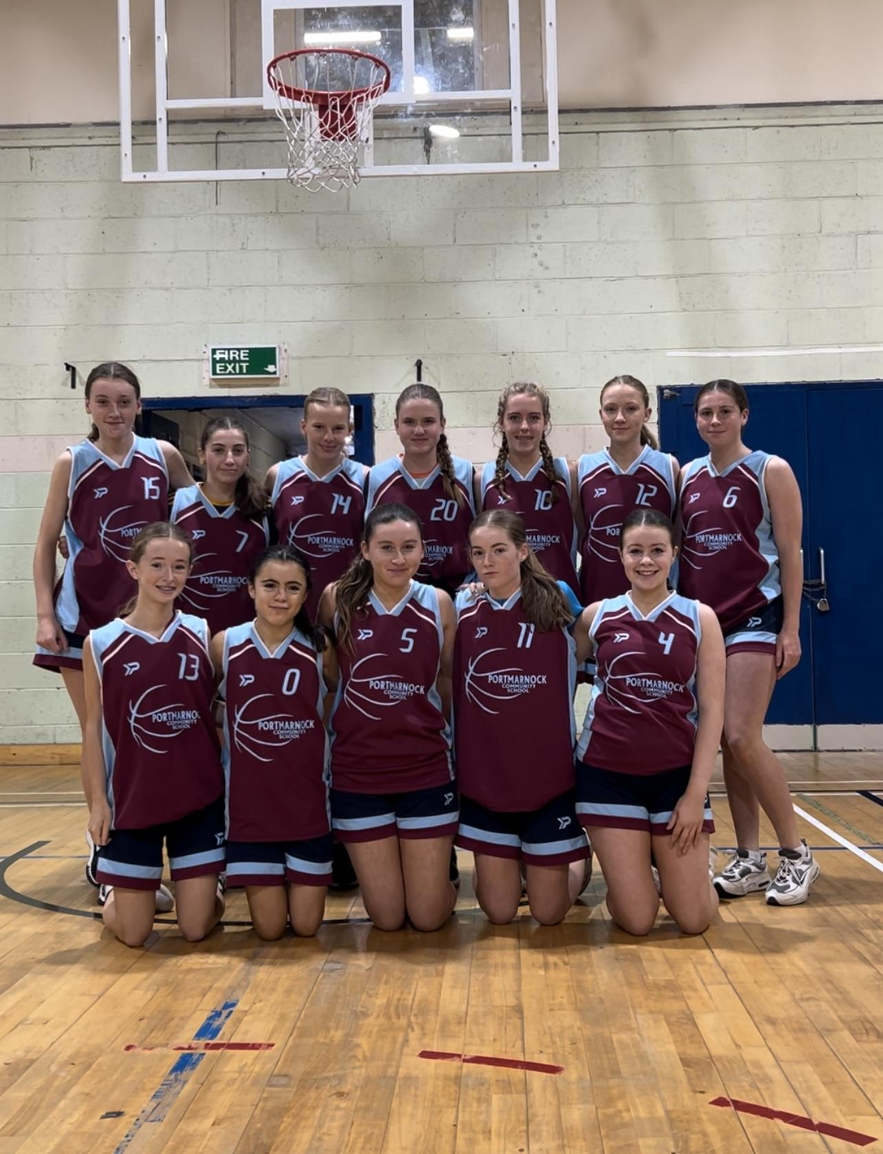
Photo taken by Jodie Wynne
(Top left-right) Naomi Crilly, Ellie Reen, Issy Harrell, Abbie Goharty, Ellen O’Mahony, Ava O’Toole, Sophie McDonnell
(Bottom left-right) Grace Plunkett , Poppy Mullan, Ella Brennan, Grace Collier, Eabha

Final score
Portmarnock - 34
Clonturk - 16

The game starts, and it’s intense from both sides. Ellie Reen and Sophie McDonnell having an immediate impact on play. The first quarter ends 7-0 to Portmarnock with Naomi Crilly, Grace Collier and Sophie McDonnell getting themselves on the scoreboard. The second quarter begins, the game resumes by Portmarnock keeping the intense pressure on Clonturk, scoring 2 more baskets. Clonturk retaliated by getting themselves their first basket followed up by another great score from Clonturk. A special mention must be made about Poppy Mullan who made some great dribbles resulting in the girls scoring. Half time is marked by Naomi scoring on the buzzer. What a first half from the Portmarnock girls.

The second half begins, and Portmarnock go out as eager as ever. Portmarnock gets many shots on the basket as the hope from the Clonturk team dwells. Scores from Noami, Poppy, Grace and Issy made the score 28-9 to Portmarnock. The final quarter begins and Clonturk makes one final attempt at getting in front but it’s no match for Issy, Sophie and Ellie who defend really well. Some great build up play from Portmarnock leads to Ellie scoring an amazing lay-up. In the final minute Clonturk scored a nice 3 pointer.

What a game from the girls! It’s a well deserved victory in Portmarnock. The score ending 34-16 to Portmarnock. Coach Paul Mullan awarded Naomi Crilly with a well deserved girl of the game, after a great performance and plenty of scores.

