On The Buzzer
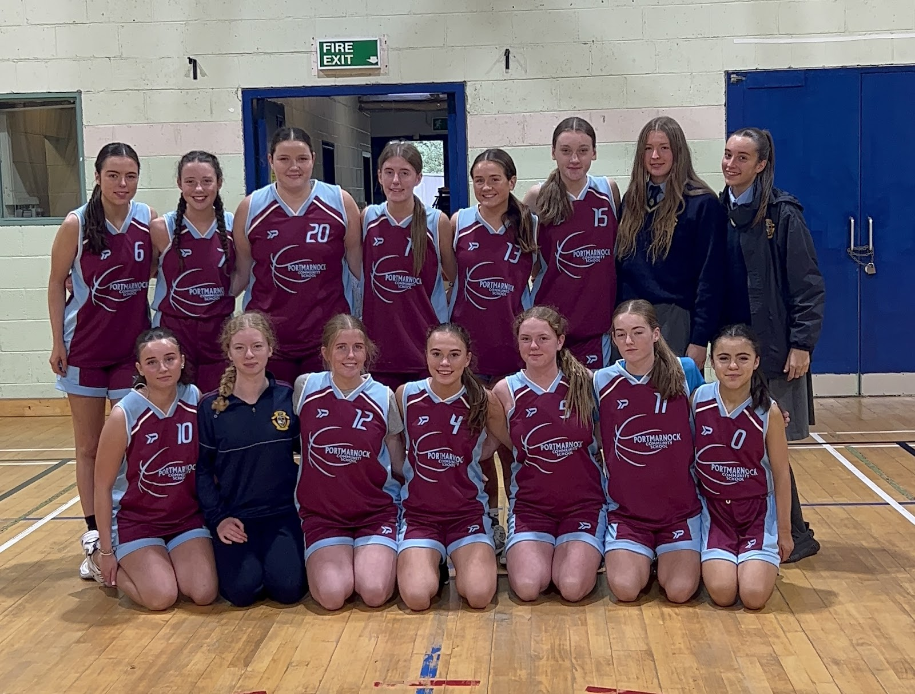
Photo taken by Jodie Wynne
Top row(left to right): Ria Mullan, Maria Hussey, Sophie Ffrench, Cerys Byrne, Kirsten Mooney, Naomi Crilly, Ava Cotter, Nicole B.
Bottom row(left to right):Emma Daly, Katie Archer, Sadhbh Rogan, Ava Carr, Anna Digan, Grace Collier, Poppy Mullan.

Final score
Portmarnock - 30
Clonturk - 32

On the 27th of September 2023, the Portmarnock U19 girl’s basketball team went up against Clonturk Community College. The game started off with a bang as in the first minute Portmarnock Captain Ria Mullan was fouled. Shortly after Clonturk scored 3 baskets all in the same 5 minutes, but this didn’t deter the spirits of Portmarnock because Ria Mullan tore through the defence of Clonturk and scored a basket putting the score at 2-6. Kirsten Mooney made some great battles but was unlucky not to get a score. At the other end of the court Sophie Ffrench defended the basket like her life depended on it. Towards the end of the quarter Ava Carr made a great lay-up scoring us 2 points but was shortly followed up by a 3 pointer from Clonturks no. 15 on the buzzer. That marked the end of the first quarter with the score being 4-10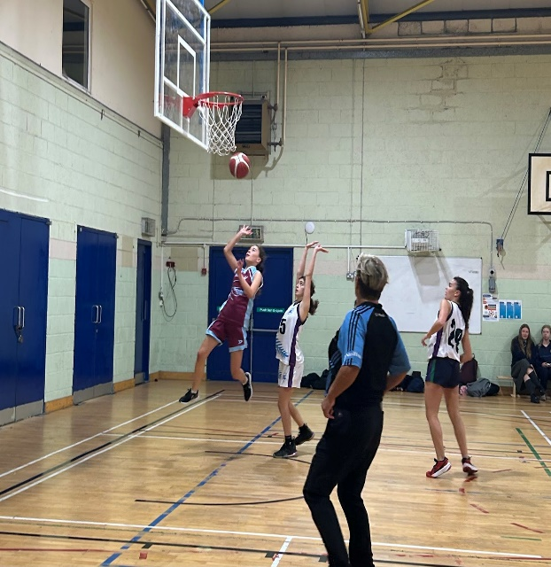

Portmarnock were on the press with Ria, Naomi and Kirsten gaining 6 points, making it all tied 10-10. Clonturk retaliated by scoring a superb 3 pointer. Maria Hussey was battling really well and putting up a great fight against Clonturk. Clonturk followed through with another basket. Kirsten Mooney was awarded a free throw where she scored 1 point. There was another free throw that Kirsten took but unfortunately nothing came from it. After a while 2 baskets were scored, one for Clonturk and one for Portmarnock. The ending score for the first half was 13-19 to Clonturk. 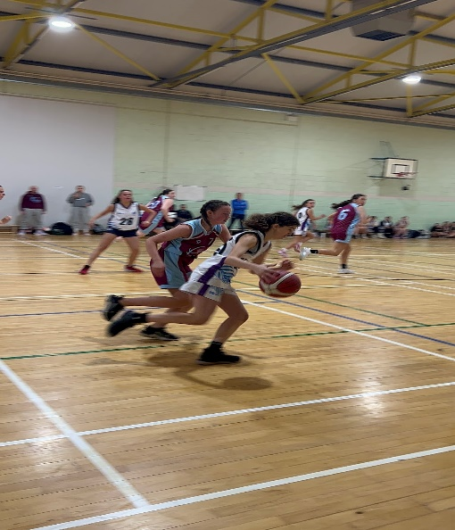

The start of the second half of the game was fast paced and Clonturk were on the press winning a free throw and gaining a point for their team. They then scored two more baskets soon after. Ria Mullan managed to get herself into another tangle while fighting for the ball. Sophie Ffrench was constantly putting the ball in for the girls to have a go at a basket, which paid off because Ria managed to put the girls two more points up. Sophie also got some glory because when the ball came in she didn’t hesitate to score. The game was end to end with Portmarnock using every chance they got. On the buzzer, Ria broke through Clonturks defence and scored a basket. To conclude the 3rd quarter with a score of 19-26 to Clonturk.

In the 4th quarter you could see that Portmarnock wanted to win and the girls won a free throw where Kristen got both points bringing the girls closer to a draw. The girls fought hard to get the next 4 points and so did Clonturk. Throughout the 4th quarter Clonturk gave away 3 fouls and showed that they also wanted to win. Maria Hussey managed to get herself into a squabble while fighting for the ball. Portmarnock got even a few minutes before the buzzer and spirits were high. The girls were wrecked and still trying their best. At the last second Clonturk scored a great basket on the buzzer leaving the score at 30-32.

Portmarnock were left devastated, as their draw was stolen at the last second. Team coach Paul Mullan awarded Kirsten Mooney with girl of the game for her amazing effort.

Written by Erica McElroy and Leah Colgan
Photography by Jodie Wynne

