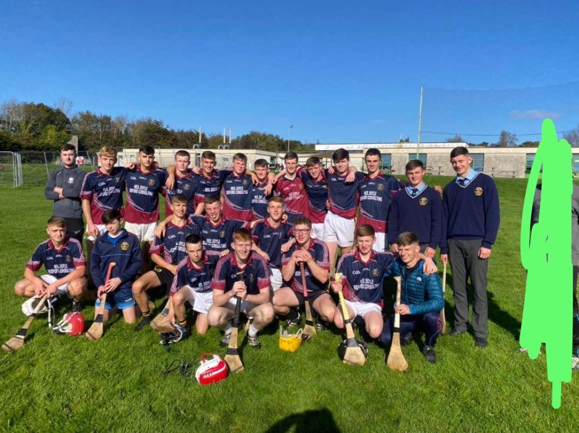
PCS VS BCS
2-4 : 2-18
This tightly contested match took place on the 12th of October.Starting team below.
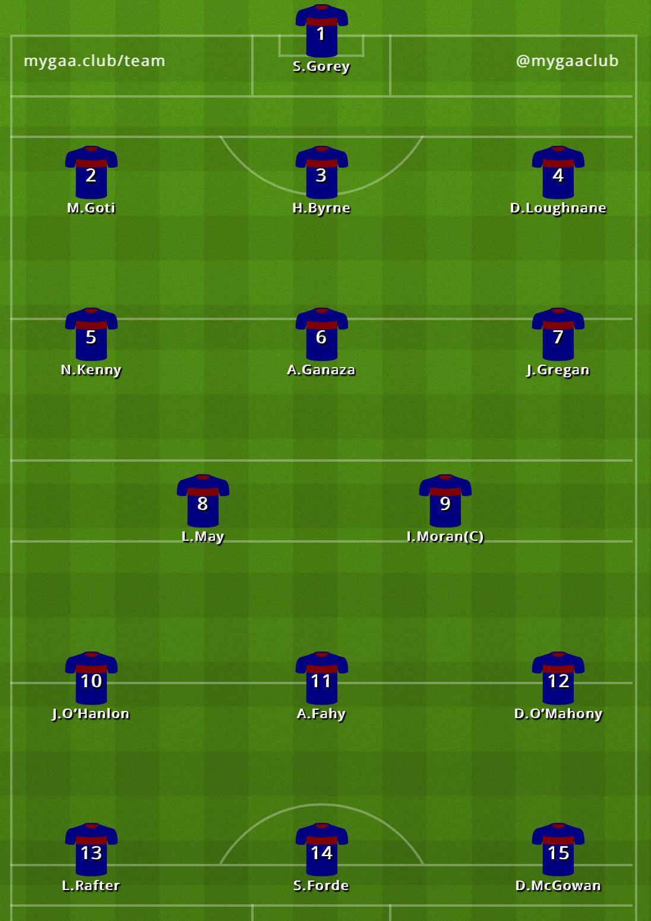
The game started off with Boyne’s no.8 turning the ball over and breaking towards goal he played it into the square and no. 14 was about to shoot and Dara ‘KDB’ Loughnane put his body on the line and got whacked by 14’s hurl in the back. James McNamee replaced him wearing no. 16.
Boyne had started the better team getting a 4 point lead early on. Aaron Fahy scored a nice free kick from 30 yards to cut the lead to 3 points.2 hurls were broken in the first 15 minutes of the game showing how the lads were battling hard. .Boyne’s number 14 was looking dangerous knocking over a few points before half time. Sean Gorey took a heavy hit for Boynes first goal but responded well with a short puck out to Ian Moran.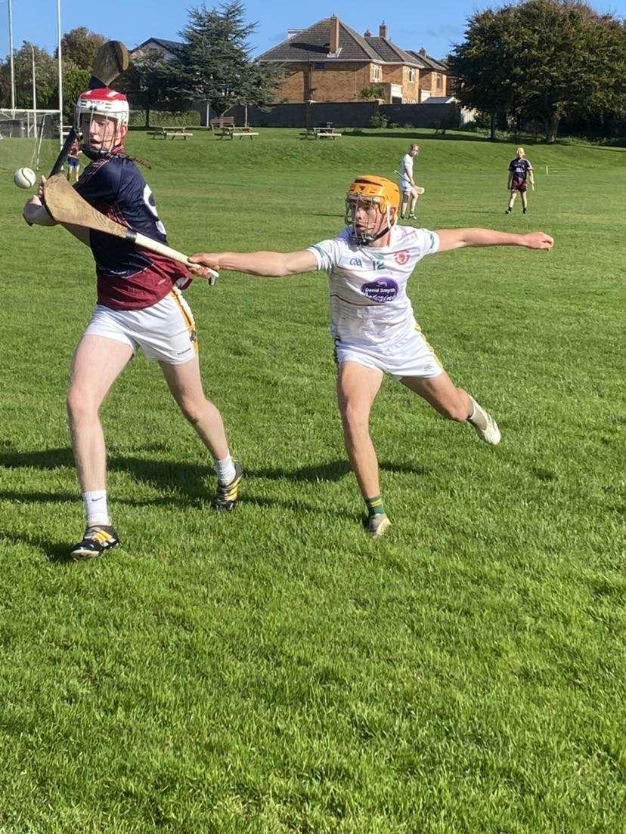
HT score:PCS:0:2 BCS:1:8
Mr.Clarke’s heroic actions saved the team from dehydration when he delivered much needed water.Mr.McNeive gave a great motivational team talk so now the lads were on the comeback trail.
Zach Fahey brought a physical edge to the second half not backing down against his marker number 7.He and the lads were battling to get back into the game.
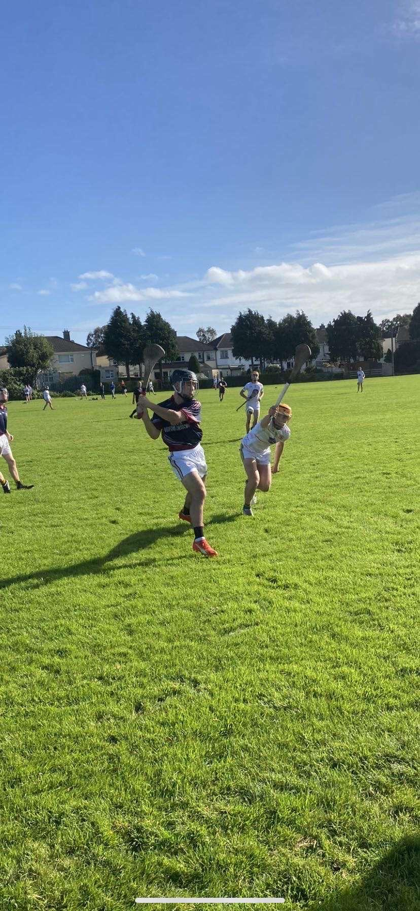
5 minutes later Fahey was sent off for an alleged verbal assault on referee Danny Harrington.
No.18 Shane Rafter came on for no.12 Daire O’Mahony. Soon his partner in crime Cillian 'Doritos’Slevin joined him in the full forward line as a replacement for the injured Luke Rafter-Boyne Timbers had been shivered.
Jake Gregan was removed from the pitch for an overly physical tackle on a Boyne player shortly after.The dangerous duo of Slevin and Rafter was being marked tightly by Protein Bor.Lenny May had a superb point knocking one over the bar from 50 yards. Soon after a great run by May lead to a fantastic team goal finished off by no.14 Sam Forde.
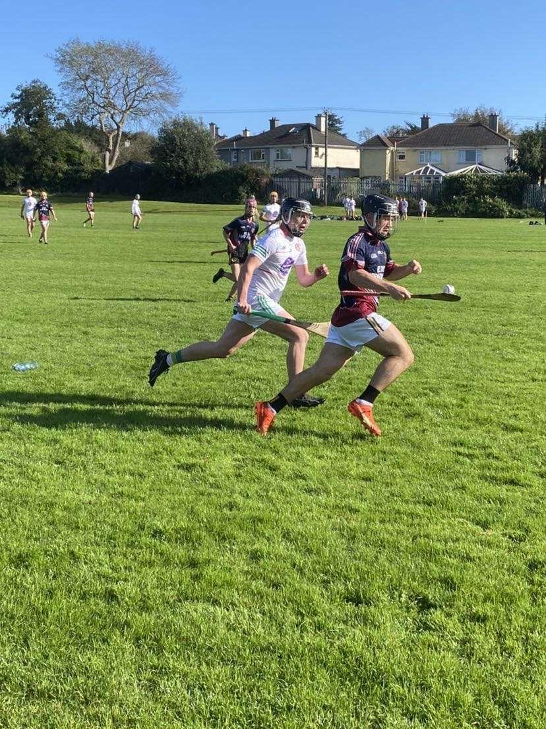
Forde scored another goal soon after, assisted by Aaron Fahy.Fahy added a point from a free minutes later.
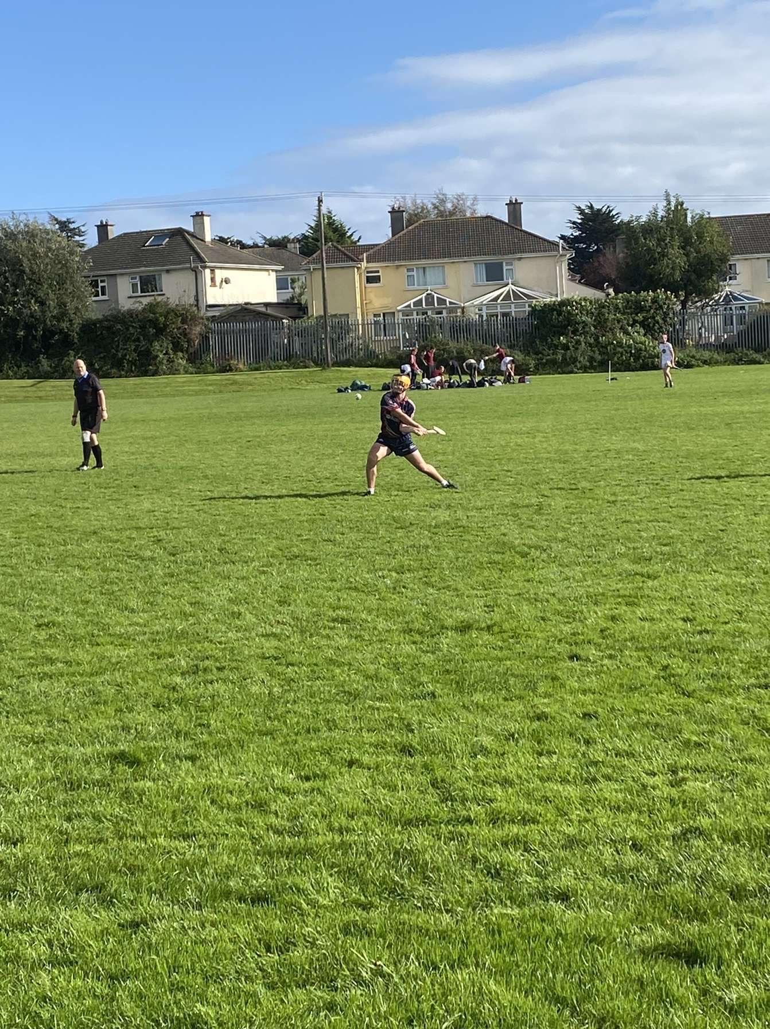
Noah Kenny was horrifically fouled by a Boyne player he reacted rashly by hitting him a smasher and Harrington sent him off. Ref did the lads no favours on the day.No.3 clattered Aaron Fahey giving away a free and Shane Rafter stepped up and hit the free over the bar for a consolation point. FT:PCS- 2:4 BCS-2-19.Tough day at the office for the lads.
Our MOTM was given to Sam Forde.
Post Match Interview:
Thoughts on the performance?
Sean Gorey:The team didn’t play well. We were missing a few key players which showed on the pitch Today.
How’s you rate the movement for the puck outs today?
Sean Gorey:I felt like the movement wasn’t good enough but the short puck outs worked well at times but the longer ones didn’t work as well.
Tough day today to go up against Protein Bor,thoughts on him?
Shane Rafter:A very nice guy,offered me a summer job on his farm.
How was your free today?
Shane Rafter:It was perfect.
What do you think about the Refs' decision today?
Are you happy with your game time?
Cillian Slevin:Yeah buzzing to just be here to be honest.

A tough day at the office for the lads but hopefully they can get their season back on track in the next match when they should have more key players back available.

