Gruelling Game

On the 3rd of October 2023 the PCS U19s boys went head to head with Pobalscoil Neasain. The match was tough from the get go but the lads stuck their ground. PSC made the first attempt but was sadly blocked by Neasain’s defence. Neasain knocked the score up by 6 points in the first quarter. They were just lucky and it didn’t reflect the Portmarnock boys skills and the team was missing a few key players who were at a GAA game. This meant a few of the lads from the U16s team were playing up. A few minutes before the buzzer went off Samuel Garofalo scored a basket leaving the score at the end of the first quarter to be 6-2 to Neasain.

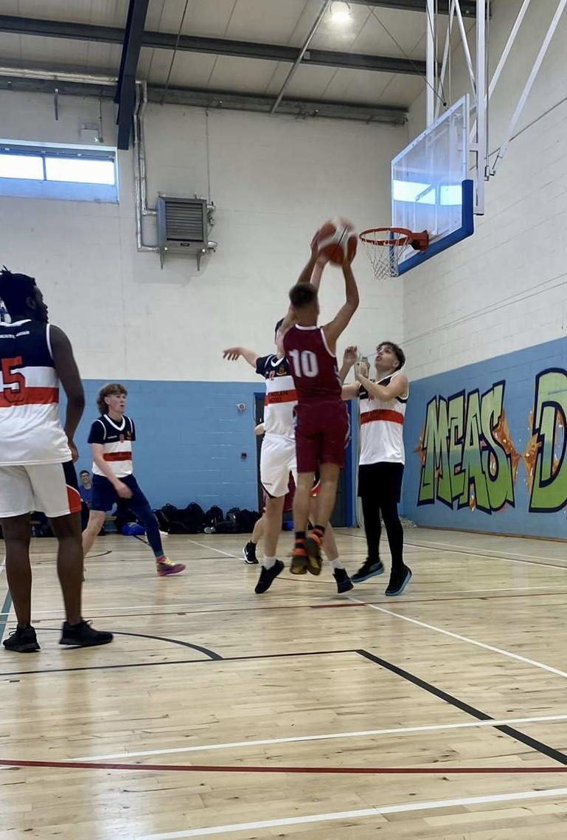
The second quarter was hard. The boys battled for the ball and gave away a free throw in which the opposition scored one. PCS retaliated by Garofalo scoring a 3 pointer. Neasáin were a tough and physical team, one example being Andrew Comiskey being knocked to the floor, and unfortunately the referee not seeing. Then few minutes later PSC got a free throw earning the boys 2 more points and putting them in the lead with the score at 7-8. Their lead was short lived as Neasain scored 2 more baskets to conclude the first half, the score being 11-9.

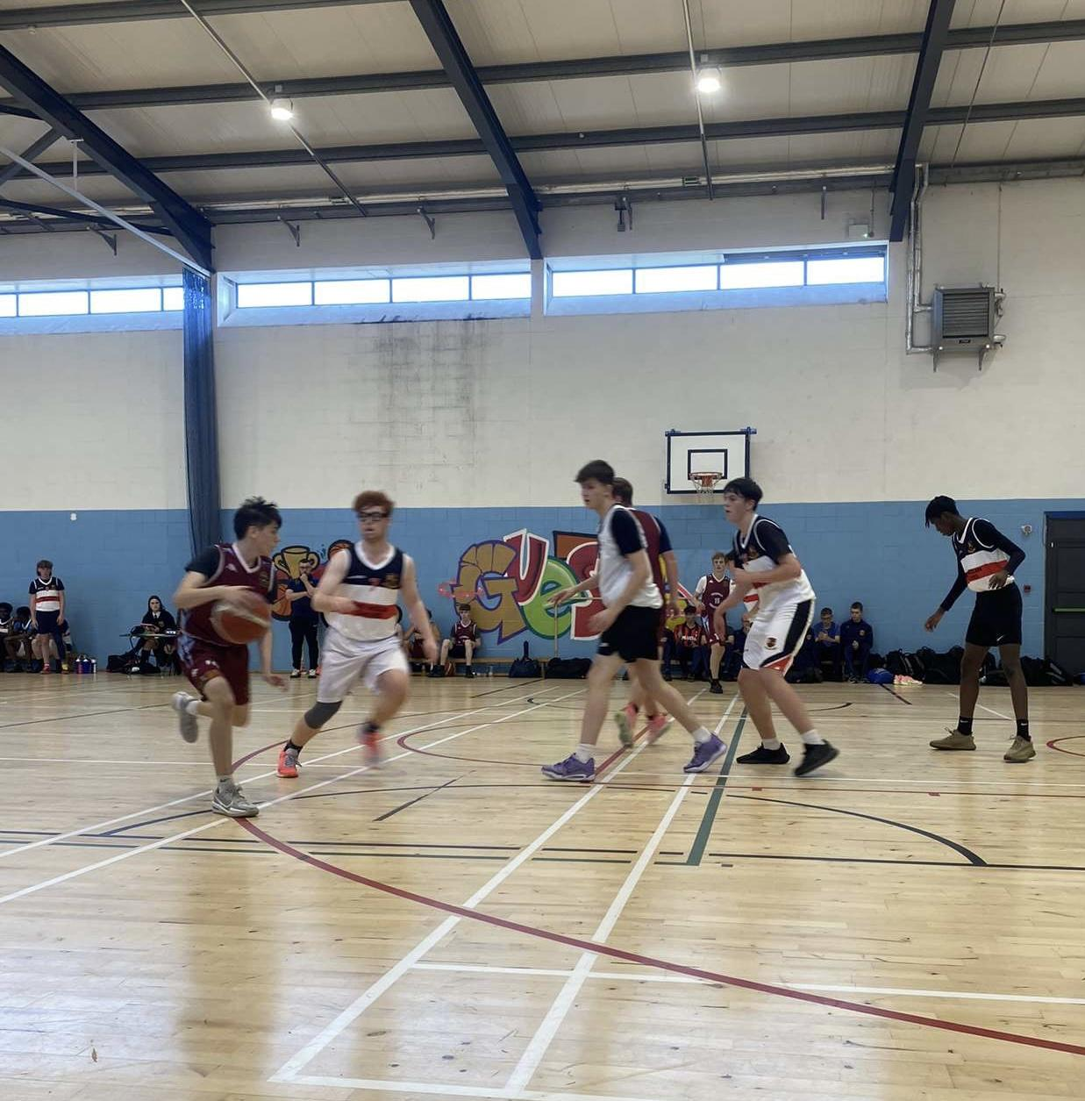
The second half began and spirits were high because PCS had been in the lead earlier on in the game so they could do it again. Scoil Neasain’s best player managed to grab himself a basket. The lads were taking every chance they could with Andrew Comisky, Martin Kostov and Kevin Li making great attempts but Neasain’s defence were on the ball. Neasain gained another 2 points and the third quarter ended with the score at 15-9 to Neasain.

The PCS boys were putting a lot of pressure on Neasain which gained them a free throw, but sadly nothing came of it. The home team managed to award themselves 3 more baskets, Samuel Garofalo gained PCS 2 points after a free throw. Comiskey scored a superb basket putting the score at 21-14. There were a few clashes, and tensions were high between players as shown by Neasain when they gave away 2 free throws. Neasain made a basket but it was disallowed. To finish off PCS’s tough game Martin Kostov made an amazing lay-up.

The final score ended at 31-18 to Pobalscoil Neasain which was unfortunate for the PCS team who played their hearts out. Man of the match was awarded to Andrew Comiskey, and a special thanks to coaches and teachers involved.

Written by Erica McElroy
Photographed by Jodie Wynne

